Turning Thin Walled Vessels
By G. Scott Hackler
Introduction:
Why do we or should we, turn thin? Turning thin can be both creative expression and of a practical use for the next stage of our turnings, such as piercing work. The sheer lack of weight can be an awe inspiring thing that fascinates fellow turners and dumbfounds the general public. The grace and elegance of a delicately thin turning elevates turning from the practical to “art”.
Beginning:
When considering a piece for thin turning, several factors come into play. Will I be doing anything with the piece after the turning phase? Meaning is the thin turning to facilitate piercing or are the thin walls meant only for reducing weight. When I am turning a vessel that I clearly have no intension of piercing but maybe some surface texturing or even just left alone, I will generally turn the walls down to a thickness between ¼” and 1/8” This serves the purpose of lightening the turning while keeping the stability intact.
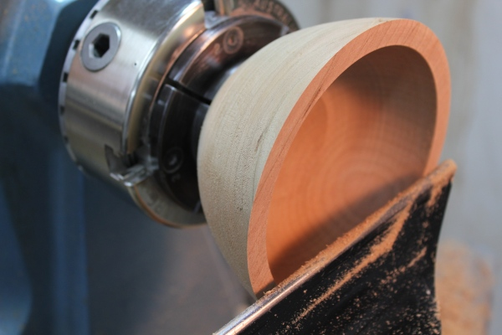
The type of wood generally doesn’t matter until you get thinner than 1/8”. After that, you will need to have chosen a species of wood that is hard enough to minimize the flex and stress while turning and will maintain enough strength for piercing if that is the end result. Closed pore varieties do very well, such as sycamore, mesquite, Osage orange, hard maple and locust. Open pore species are not as suitable for walls thinner than 1/8”. Such varieties would include walnut, pine, cedar and such. A lot of consideration of the type of wood should be focused on IF the piece is to be pierced or carved after turning.
The tools needed are the standard gouges that every turner should own, a small scraper and set of calipers, a light source
For a thin walled open form, you will turn it just like every other bowl, stopping the wall thickness at about ½” to ¾” before proceeding. You should completely sand the exterior of the piece prior to turning the walls down, because of the flexing potential of the thin walls. Sanding the outside first allows for the use of power sanding!
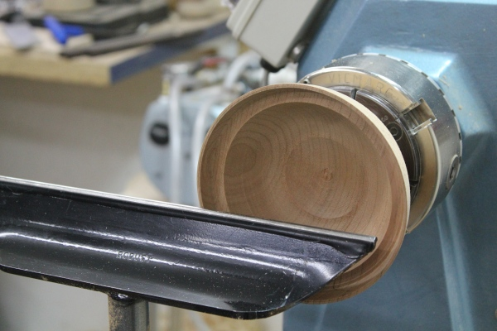
Tip number one… SHARP TOOLS!! I use a CBN wheel on my slow speed grinder for sharpening, but in between trips to the grinder I use a diamond hone to freshen up the edge. A super sharp tool is necessary to turn thin because of the reduced pressure to cut the wood. Pushing a dull tool will cause flex, chatter and sometimes…explosions! While we are thinking about explosions, please wear a safety helmet when doing potentially hazardous activities such as woodturning, especially while doing thin walled turning where there is a higher probability of turning through a piece!
The thinning process:
The very first and most important step in turning thin is to finish the outside shape, before starting on the interior. This establishes the visual aspect of your piece and enables you to concentrate on the shape of the form, first.
Start to hollow out the inside using your preferred method and take the wall thickness to ¼” to 1/2”. This will allow for plenty of wall strength as you continue the tinning. Start at the rim and only work on less than 1” of the wall…. at a time, slowly turning the vessel walls thinner. The thickness of the rest of the bowl will support the thinner portion from flexing under the pressure of the tools.
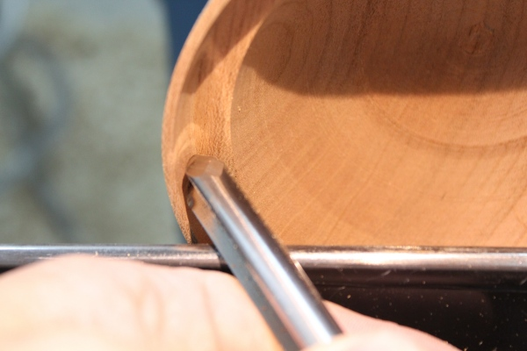
There are several methods for tool presentation. The standard “push cut” and a modified scraping cut with the gouge turned almost 90 degrees to the left. I use both, but prefer to turn the gouge to the left and reduce the interior in this manner. For me, it allows for easy cleanup of the tool marks and blending from one section that is just being thinned to the previous section. Again, it must be stated that a dull tool is your enemy, keep the tools sharp.

Measuring:
To thin a vessel consistently, you will need a method of measure. You can use calipers, by feel, by sound (yes I said sound!) and by using light. I have used all of these methods and you will have to experiment to find the method(s) that work better for your style of turning.
- Calipers are pretty self-explanatory. The key with them is to find a way to quickly note the desired thickness and check the piece continually to ensure consistent wall thickness.
- Touch is a tricky skill that you develop through the use of calipers and touch to confirm that you are actually feeling the “real” thickness. This is generally done with one finger on the inside and one on the outside.
- Sound is a method that involves listening to the wood. When the wood reaches a certain thickness it will resonate and create a high pitched squeal. Don’t confuse this noise with the chatter sound. When you hear the high pitch noise, the wood is likely as thin as it will allow without movement. Past this point the chattering will start and by then …it’s too late. You will have either cut through the piece or chattered the interior wall beyond repair.
- Light is a very valuable thinning tool in light colored woods. You start by turning the first inch or so of the vessel to establish your desired thickness and by placing a light source on the outside of the vessel you will see the light shining through the wall of the piece. Now you just slowly move the light to the next area and turn the walls down until the light shining through looks consistent.
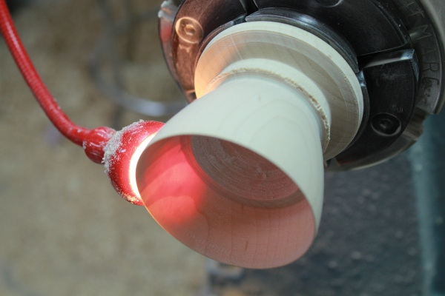
SAFTEY WARNING: NEVER CHECK THICKNESS WITH THE LATHE ON.

Speed of the lathe:
You should turn thin walled vessels as fast as you are comfortable with. This will result in less time spent in an area and less chance for tool marks. Keep in mind that the faster that the lathe spins, the faster the material is removed. I tend to turn faster than a lot of folks, so I am comfortable with the lathe running faster. Don’t put yourself at risk, but experiment with speed while thinning and you will see the difference in ease of turning and the results in your piece. The main technique is to remember to finesse the wood lightly, don’t try to “hog it out” when thinning.

The transition to the bottom:
Whether you are turning a bowl, goblet vase or cup… they are all just bowls shaped different. Treat the transition the same. Bottoms are generally left a tad thicker to stabilize the piece. On a vessel that have 1/8” walls I will shoot for a ¼ thick bottom, or about double the wall thickness. It is helpful to visualize the exterior of the piece, through the remaining stock/tenon and find the invisible bottom. With one eye closed and your head perfectly still, you can use a ruler or even just a stick to lie across the outside of the piece in a way that places the end of the stick just shy of the “invisible” bottom. Note the measurement on the ruler or mark the other end of the stick (at the rim) with your finger. Now while keeping the same eye shut and with your head still in the same location, place the measuring device inside the piece and see the difference.
This quick and fast method allows for a fast depth reading. Once the desired depth is reached, you should focus on transitioning the wall to this depth. Keep in mind that at some point, measuring the wall thickness close to the bottom will be impossible, since there is likely waste wood or the tenon still in place. Just continue the same, graceful curve to the center of the piece and you will mimic this curve in the last step, on the outside of the piece.
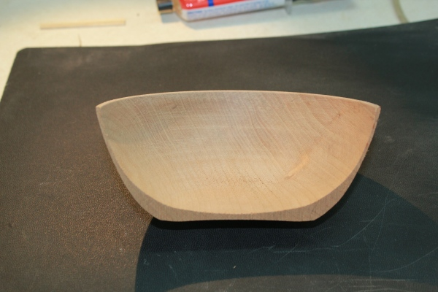
Finishing the outside to the “invisible bottom”:
Because the walls will generally taper thicker towards the bottom you might want to increase the curvature of the exterior at the bottom. Use a very light touch/cut for this step and never move up onto the middle to top portion of the sides as they are flexing too much to turn again. Utilizing a push cut method; continue your curve to the “invisible bottom”. Note that your interior has a defined curvature and you need to be mindful of this curve and the measurement of the depth or you will quickly create a thin walled funnel! It is, hands down, safer and easier to establish your exterior curve…first.
Once the inside is thinned and you are ready to finish the bottom, either part or turn it off of the waste stock/tenon. On these types of vessels I will use of a jam chuck but carefully, because of the pressure against the thin walls. A vacuum chuck will work as well as long as you take it easy of the vacuum pressure. I will often turn the bottom to a ½” tenon and then saw it off the remaining waste material. Better to do this then ruin an hour or more of work! If you have a vacuum chuck you could use it to completely clean off the small tenon. If not, just carve it off with a rotary tool sing a sanding drum or some 220 grit on a small sanding disc.
Now you have a thin walled vessel that you can pierce or just amaze your audience or even use as a lamp shade!

